TUOM_4COL**Appendix 5 - DIRECTORATE OF ESTATES & FACILITIES - PROJECT STAGE SIGN OFF RECORD**

|  |  |  |  |
| --- | --- | --- | --- |
| **Project Number:-** | **……………………………………………..** | **Gross Value (£):-** | **……………………………………………..** |
| **Project Name:-** | **……………………………………………..** | **Completion Date:-** | **……………………………………………..** |
| **Building:-** | **……………………………………………..** | **Funding Source:-** | **……………………………………………..** |

**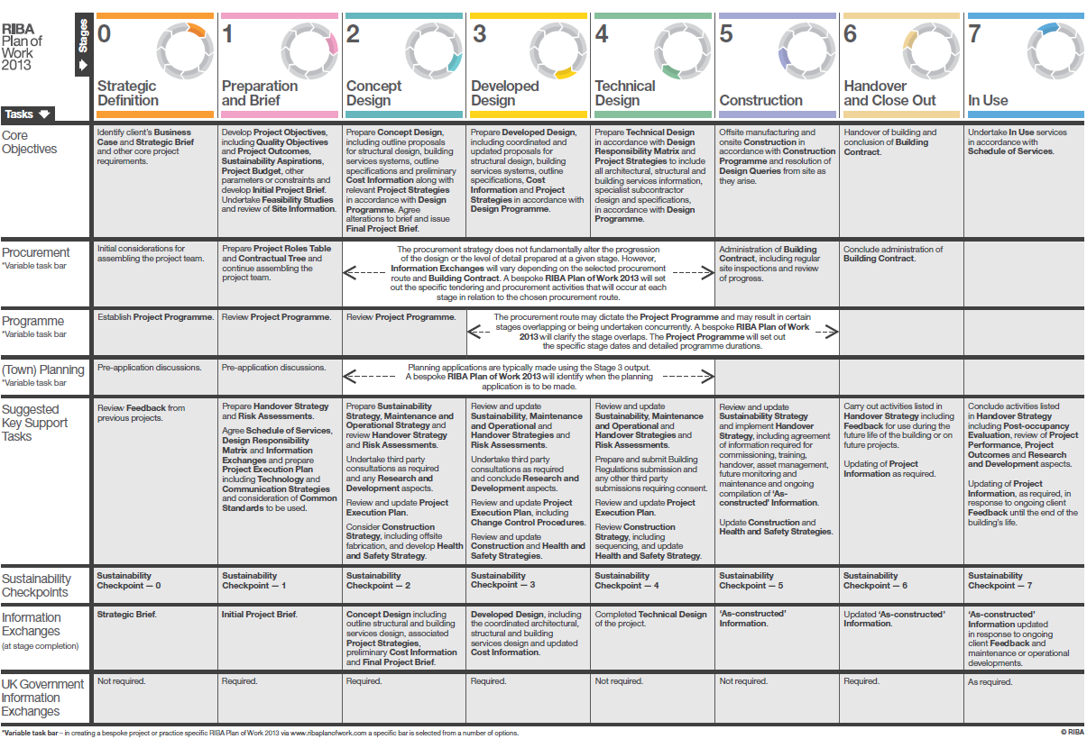**

|  |  |  |  |  |  |  |  |  |  |  |  |  |  |  |  |  |
| --- | --- | --- | --- | --- | --- | --- | --- | --- | --- | --- | --- | --- | --- | --- | --- | --- |
|  | **Signature** | # | **Signature** | # | **Signature** | # | **Signature** | # | **Signature** | # | **Signature** | # | **Signature** | # | **Signature** | # |
| Head of Professional Services |  |  |  |  |  |  |  |  |  |  |  |  |  |  |  |  |
| Head of Design Services |  |  |  |  |  |  |  |  |  |  |  |  |  |  |  |  |
| Head of Capital Projects |  |  |  |  |  |  |  |  |  |  |  |  |  |  |  |  |
| Head of Maintenance  Services |  |  |  |  |  |  |  |  |  |  |  |  |  |  |  |  |
| Head of Estates Operations |  |  |  |  |  |  |  |  |  |  |  |  |  |  |  |  |
| Principal Building Surveyor |  |  |  |  |  |  |  |  |  |  |  |  |  |  |  |  |
| Principal Mechanical & Energy Engineer |  |  |  |  |  |  |  |  |  |  |  |  |  |  |  |  |
| Principal Electrical Engineer |  |  |  |  |  |  |  |  |  |  |  |  |  |  |  |  |
| Fire Officer |  |  |  |  |  |  |  |  |  |  |  |  |  |  |  |  |
| Asbestos Manager |  |  |  |  |  |  |  |  |  |  |  |  |  |  |  |  |
| Head of Environmental Sustainability |  |  |  |  |  |  |  |  |  |  |  |  |  |  |  |  |
| Waste Co-ordinator |  |  |  |  |  |  |  |  |  |  |  |  |  |  |  |  |

**# Tick box if sign off subject to comments provided being addressed**

|  |  |  |  |
| --- | --- | --- | --- |
| **Project Consultant Team** | **Insert on Appointment** | **Project Consultant Team** | **Insert on Appointment** |
| Internal Project Manager |  | Architect |  |
| External Project Manager |  | Building Surveyor |  |
| QS |  | CDM-C |  |
| M. Eng |  | S. Eng |  |
| E. Eng |  | Other …………………………………… |  |